Date 2071-1-7
Due date 2071-4-20
- Construct a truth table for compound proposition. [5]
$$\left(p→q\right)↔\left(¬p→¬q\right)$$
- Show that
$\sim \left(p∨\left(\sim p∧q\right)\right)$And$\sim p∧\sim q$are logical equivalent by developing a series of logical equivalent. [5]
- Determine whether this argument is valid or invalid by using truth table . [5]
I play Golf or Tanis.
If it is not Sunday, I play Golf and Tanis.
If it is Saturday or Sunday then I don’t play Golf.
Therefore, I don’t play golf.
- Prove that the square of even integer ends in 0, 4 or 6. [5]
- Prove that between every two rational number there is an irrational number. [5]
- Prove that between every rational number and irrational number there is an irrational number. [5]
- Prove that $\sqrt{2}$ is irrational number. [5]
- Prove or disprove the statement [5]
“The square of every integer ends in 0, 1, 4,5 or 9”.
- Let $G=\left(V,E\right)$ be undirected graph with e edges then [5]
$$2e=\sum_{u∈v}{deg\left(u\right)}$$
- An undirected graph has even number of vertices of odd degree. [5]
- Let $G=\left(V,E\right)$ be a graph with directed edges then [5]
$$\sum_{v∈V}{\deg^{-}\left(v\right)}=\sum_{v∈V}{\deg^{+}\left(v\right)}=\left|E\right|$$

- A simple graph is bipartite if and only if it is possible to assign one different colors to each vertices of the graph so that no two adjacent vertices are assigned the same color.
- Determine whether the graph G and H are Isomorphic.
v₁
u₃
u₄
u₅
u₆
v₂
v₄
v₅
v₆
G
H
v₃
u₂
u₁

- A connected Multigraph with at least two vertices has a Eular circuit if and only if each of its vertices has even degree.
- A connected multigraph has anEular path but not an Eular circuit if and only if it has exactly two vertices of odd degree.
- Find a rout with the least total airfare that visits each of the cities in the graph, where the weight on an edge is the least price available for a flight between two cities.

Settle
Bosten
$119
$319
$239
$229
$409
$389
$109
$379
$429
New York

$309
New Orleans
Phoenix

- Let G be a connected planner simple graph with e edges and v vertices, let r be the number of region in a planner graph represent of Gthen$r=e-v+2$.
- What is the chromatic number of graph C_{n} where n≥3.
- A graph is connected if and only if it has sub graph that is a spanning tree.
- A complete bipartite graph K_{m,n} is planner if and only if m≤2, n≤2
- Find the explicit formula for the Fibonacci number.
- What is the solution of the recurrence relation
$$a_{n}=6a_{n-1}-9a_{n-2}$$
- Find the solution to the recurrence relation
$$a_{n}=6a_{n-1}-11a_{n-2}+6a_{n-3}$$
- Find the solution to the recurrence relation
$$a_{n}=5a_{n-1}-6a_{n-2}+7^{n}$$
- Find the solution to the recurrence relation
$$a_{n}=a_{n-1}-6a_{n-2}+2^{n}+3n$$
- Draw the state diagram for the finite state machine with these state tables.
a)

b)

c)

- Give the state tables for the finite state machines with these state diagrams

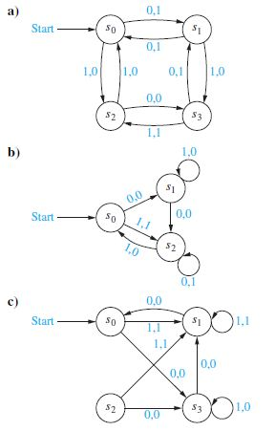
- Determine the shortest path between the vertices a to g of following graph.
a
b
a
d
c
f
30
19
14
10
23
11
20
35
40
50
6
8

g

